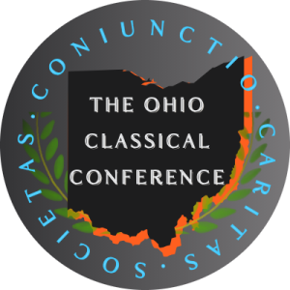
Call for Papers, Undergraduate Panel Ohio Classical Conference, 104th Annual Meeting,
September 25th and 26th, 2026 Columbus Academy, in Gahanna, Ohio.

The 104th annual meeting of the Ohio Classical Conference invites submissions for its undergraduate panel! This year’s meeting will be held at Columbus Academy in Gahanna, Ohio, on Friday and Saturday, September 25th and 26th, 2026. Papers might address any topic related to classics, ancient history, ancient Greek or Roman philosophy, classical archaeology, or classical reception. They should be no more than 1,500 words (or 10 minutes) in length.
Four papers will be chosen for the hour-long undergraduate panel: each presenter will speak for 10 minutes and ﬁeld questions for ﬁve more minutes.
If your paper is accepted, the OCC will fund your transportation, hotel, food, and conference fees, up to $500. However, we would be delighted if you could join us for the meeting whether you submit a paper or not: besides this panel, the conference includes a graduate and professional panel, a banquet speech by Monica Cyrino of the University of New Mexico, a keynote speech (featuring Bryan Doerries, author of The Theater of War: What Ancient Greek Tragedies Can Teach Us Today), the Vergilian luncheon address, live reading of passages from the first book of Homer’s Iliad in Greek and English, and other events.
Submissions must be in the form of a solid draft of the talk. The deadline for submitting a paper is Monday, June 8th, 2026. A panel of professors will read the submissions and select papers for the conference by the end of June. Please send all submissions (or any questions) to Professor Edith Foster at OCCpapersubmission@gmail.com. Again, the deadline for submitting a paper is Monday, June 8th, 2026.

