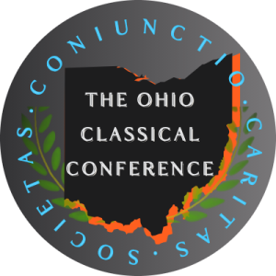
Call for Papers: Ohio Classical Conference, 104th Annual Meeting,

September 25th and 26th, 2025 Columbus Academy, in Gahanna, Ohio.

Professional Panels
The 104th annual meeting of the Ohio Classical Conference invites colleagues from Ohio, the United States, and Canada to submit abstracts for its professional panels. Abstracts should be 200 to 400 words long. The theme of this year’s meeting is performance, in all its aspects, but abstracts may address any topic related to classics, ancient history, ancient Greek or Roman philosophy, classical archaeology, or classical reception. Papers to be held at the meeting should be no more than 15 minutes in length and should oﬀer reﬂections that will be interesting to a broad audience. We would be delighted if you would share your on-going research with all of us!

Abstracts will be blind reviewed. To this end, please leave no trace of your identity on the abstract itself. The deadline for submitting abstracts is June 8th, 2026; responses will be sent out by the end of that month.

Please join us for the meeting on September 25th and 26th whether or not you submit an abstract! Besides professional panels, the conference includes a banquet speech, a keynote speech (featuring Bryan Doerries, author of The Theater of War: What Ancient Greek Tragedies Can Teach Us Today and alumnus of Kenyon College), the Vergilian luncheon address, live readings in ancient Greek and English, graduate and undergraduate panels, and other events. The annual meeting of the OCC oﬀers a rare and excellent opportunity to connect with classics students, high school teachers, and colleagues.

Please send all submissions (or any questions) to Professor Edith Foster at OCCpapersubmission@gmail.com. Again, the deadline for submitting an abstract is Monday, June 8th, 2026.

