THE OHIO CLASSICAL CONFERENCE ANNUAL MEETING MMXXIV

TWO OPPORTUNITIES to PARTICIPATE in READING GREEK TRAGEDY
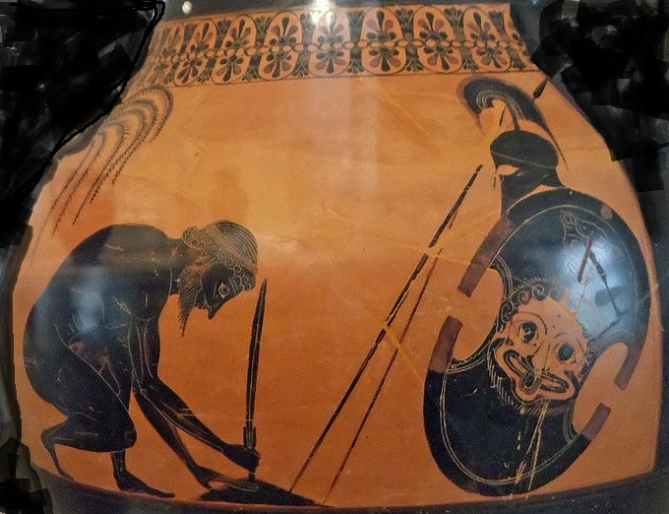

Reading of Sophocles’s Ajax in the original Greek
Friday 27 September 2024 from 1:00 – 3:00 p.m. Holiday Inn-Columbus Airport
Readers may bring their own print or digital Greek texts of the play. The Loeb edition edited and translated by Hugh-Lloyd Jones is preferred.

Walk-through of Sophocles’s Ajax in English
Saturday 28 September 2024 from 1:00 – 2:45 p.m. Columbus Academy, Gahanna, Ohio
English translations will be available to the first fifteen readers to respond. Readers must be registered for the annual meeting, agree to the terms of the media release form, and be present to participate in the walkthrough of the play, which will include both reading the play in English and engaging in some basic stage movement with other amateur actors/readers.

Those interested in participating in either the Greek reading or the English-language walkthrough, as well as those with questions, should contact Dr. Timothy Wutrich by
e-mail (trw14@cwru.edu) or telephone (216-368-6026).

We hope to see many of you at one or both of these events!

